**Assignment Title**

***Implementation of Static and Dynamic Routing using Cisco Packet Tracer***

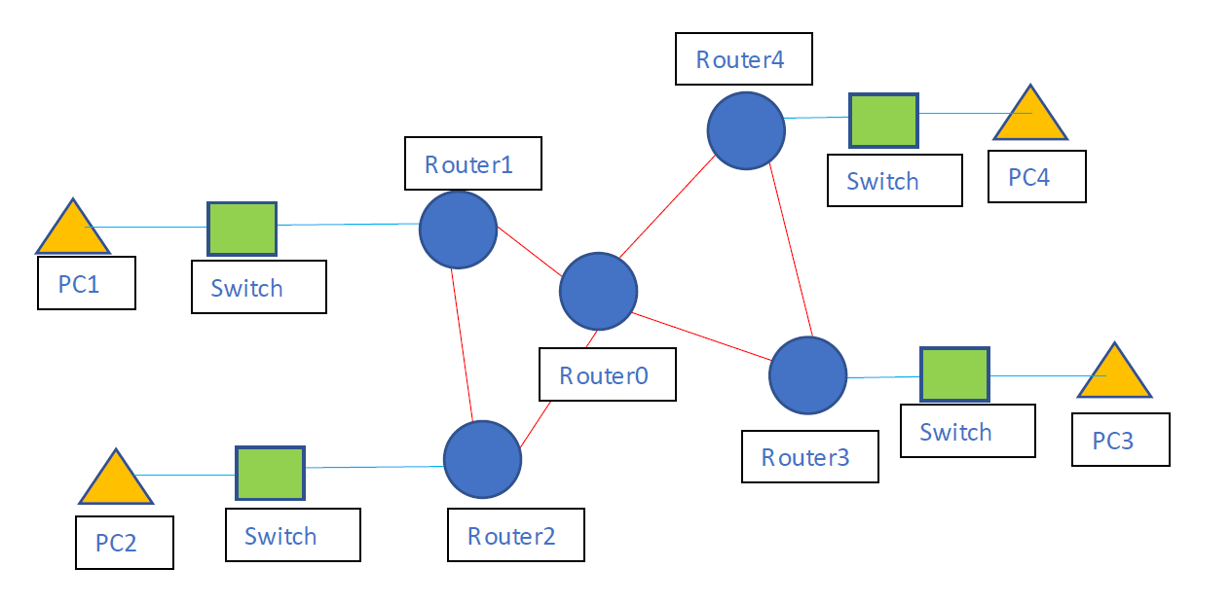

Figure: Topology

**Task Description:**

**🔹 Step 1: Topology Design**

* Create the provided topology in **Cisco Packet Tracer**.
* Use 5 routers, 4 switches, and 4 PCs, **exactly** as shown in the diagram.

**🔹 Step 2: Renaming**

* Rename **all routers** with your own name, followed by their original ID.
  + Example: Router0 → Karim0, Router1 → Karim1
* Ensure names are **visibly labeled** in the topology.

**🔹 Step 3: IP Addressing**

* Assign appropriate **IP addresses** and **subnet masks** to all devices.
* Document your IP addressing scheme in a **table** in your report.

**🔹 Step 4: Routing Configuration (2 Parts)**

**Part A: Static Routing**

* Configure **Static Routing** on all routers so that:
  + All PCs can communicate with each other.
* Take **screenshots** of:
  + Each command entered.
  + **Routing Table** (show ip route)
  + **Ping success** between distant PCs (e.g., PC1 ↔ PC4)

**Part B: Dynamic Routing**

* Remove static routes and implement **Dynamic Routing** using **RIP** .
* Configure routing protocol on all routers to share routing info.
* Take **screenshots** of:
  + Each command.
  + **Successful ping** again between PCs.

**📝 Assignment Report Must Contain Following Sections**

**1. Introduction**

* Brief explanation of the task

**2. Topology Overview**

* Insert the **topology image** you designed in Packet Tracer.
* Indicate renamed routers.

**3. IP Addressing Table**

| **Device** | **Interface** | **IP Address** | **Subnet Mask** | **Remarks** |
| --- | --- | --- | --- | --- |

**5. Static Routing Configuration**

* Step-by-step procedure with screenshots:
  + IP assignment
  + Static routing commands
  + Verification: show ip route, ping

**6. Dynamic Routing Configuration**

* Step-by-step procedure with screenshots:
  + Routing protocol commands
  + Verification: show ip protocols, ping

**7. Result & Output**

* Show **ping result** between at least **two different PCs**.
* Include **screenshot of successful data transfer (ping reply)**.

**8. Conclusion**

* Comparison between Static and Dynamic Routing
* Challenges and what you learned